Personal Finance Manager

A MINI PROJECT REPORT

Submitted by

Group No/Team No: G21/T10

Keshav Bhalla, 2301991869

Kavita Sharma,2301991868

Kashish Sharma,2301991867

in partial fulfilment for the award of the

degree of

BACHELEOR OF ENGINEERING

in

COMPUTER SCIENCE & ENGINEERING



CHITKARA UNIVERSITY

CHANDIGARH-PATIALA NATIONAL HIGHWAY

RAJPURA (PATIALA) PUNJAB-140401 (INDIA)

October 2023

# Abstract

The Title Of the project is “Personal Finance manager”. The purpose of the project is to help our website user to reach their future financial goal whether it is to buy a home in future or do a bigger investment in different plots or to resolve their financial status problems. Our user can have a talk with the most professional finance managers on our website who are ready to help them eagerly. There are two main problems solved by our website. First, is to help our website user to reach their future financial goal. For example, a person thinks of buying a house in future and his current financial situation is not as good to meet the requirements for this goal. So, he can register with us so that we can help him and many more others like him to rectify problems that are stopping them to reach their financial goal. But why choose our website if a personal finance manager can help them in his/her office? Answer is simple: ‘Paper load’ . Even though a person can reach out to a finance manager for different solutions to their problems but they’re might a lot of paperwork involved and lot of travelling might be involved in this task. So rather than this, why not spend valuable time to you manage your money by sitting just at home, avoiding paperwork and using a user-friendly graphics website which is easy to use. Few important features in our website are Graphs, Notifications, Animations and Calculators. We have used HTML and CSS (all three: Internal CSS, External CSS, Inline CSS) and JavaScript and bootstrap to make our project. We have used Visual Studio Code to write our codes. A unique Feature we have added in our website is that we have provided our user not only with expense calculator but also with other different types of calculators. For example, Loan Calculator, Saving Calculator, Budget Calculator. Making the website was interesting and fun and we learnt many topics for example Introduction to HTML, More on HTML, Forms, Introduction to CSS, Styling with CSS, Flex, More on styling, Responsive Design bootstrap, for backend JavaScript.

# TABLE OF CONTENTS

|  |  |  |
| --- | --- | --- |
| Sr.no | Sec on | Page no |
| 1 | Introduction | 4 - 7 |
| 2 | Problem Statement | 8 |
| 3 | Technical Details | 9 - 21 |
| 4 | Key Features | 22 - 23 |
| 5 | Project Highlights | 24 - 26 |
| 6 | Bonus Feature | 27 |
| 7 | Conclusion | 28 |
| 8 | Reference/Links used | 29 |

# INTRODUCTION

Personal Finance Manager

“LIVE YOUR FINANCIAL LIFE STRESS FREE”

The title of the project is --- “Personal Finance Manager”.

The team members are --- Keshav Bhalla (2301991869)

Kavita Sharma (2301991868)

Kashish Sharma (2301991867)

Personal Manager is about meeting your personal financial goals. These goals could be anything—having enough for short-term financial needs, planning for retirement, or saving for your child’s college education. It depends on your income, spending, saving, investing, and personal protection (insurance and estate planning). Managing personal finances has become more dynamic in recent times. It is not restricted to investment and budgeting anymore. There are several courses of action that play an instrumental role inefficient financial management. A personal finance manager offers ways to manage your money better and chalks out plans to help you achieve your financial goals.

Personal finance applications do not help you save money, but the insights they provide and the habits they reinforce will. The main value that your financial application should provide to users is the knowledge they need, plus tips for developing the right money management habits.

Spending trackers help you keep tabs on your spending, categorize it, and identify spending trends. Let’s take a look at the ways this goal is achieved with competing applications, and consider how you can offer users a better experience in case you decided to build an app.

A personal budget app is a technology solution that is connected to your banking account and transfers data about your income and spending, reveals your money management habits and patterns, and suggests better ways to spend your disposable income based on your financial goals. Of course, financial applications can have a wider or narrower set of functions depending on the user’s problems they are solving and the value they are providing.

WHAT IS A PERSONAL MANAGER?

A personal finance manager is someone who has mastered the skill of customised and personalised financial management. They are professionals who guide you on how to manage your money. This includes planning your investment, expenditure, insurance and tax strategies.

Personal finance managers review your current financial health and curate a plan to help you meet your financial goals. For example, let us say your financial goal is to buy a real estate property a few years down the line. To achieve this goal, you need to make sure that you have a strong financial standing. A personal finance manager helps you achieve this high-value goal through systematic planning and investments.

A personal finance manager essentially assists you to map your dreams to reality. They suggest how much money you should save, the types of accounts you must opt for, the kinds of investment products you should invest in, and much more. Besides financial planning, they also take care of you and your family by urging you to invest in health and term insurance and creating a contingency fund that you can access in case of an emergency.

Another significant advantage of availing of the services of a personal finance manager is that you get an investment plan customised to suit your needs. Such a plan is entirely based on your current financial position – affordability, preferred investment instruments, investable assets, etc. A personal finance manager regularly monitors your money and accordingly make changes in your financial plan to ensure that your financial goals do not become stagnant. Regular monitoring also allows you to analyse your expenditure pattern and cut down on unnecessary expenses.

WHAT DOES A PERSOANL FINANCE MANAGER DO?

The job description of personal finance managers is a lot more complicated than what it appears to be at face value. They take up multiple tasks to thoroughly study your financial needs and develop the best possible plan.

The key to getting your finances on the right track is using skills you likely already have. It’s also about understanding that the principles that contribute to success in business and your career work just as well in personal money management. Three key skills are finance prioritization, assessing the costs and benefits, and restraining your spending.

## USE OF FINANCE CALCULATORS

The calculators which we provide, performs financial functions commonly needed in business and commerce communities (simple interest, compound interest, loan, budget, investment, etc.). It simplifies the user’s task by providing a helping hand Finance calculator is a specialized tool designed to perform various calculations and solve financial equations. It provides speed, precision, and convenience for anything from budgeting to finance planning.

Some calculators present in our website are: -

* Investment Calculator
* Budget Calculator
* Loan Calculator
* Saving Calculator

These free calculators, tools and quizzes can help you navigate your financial journey. Use them to create a budget, figure out how much to save for retirement, find your debt-free date and more.

An investment calculator helps an individual to determine the approximate period of his/her investment savings. One can also determine the amount of savings that can be worth investing in and the time period it might last. So, whether one has started investing or whether they have been investing for some time, an investment calculator can help one to find out how to meet their goals.

### GRAPHS THE HELPING AID

Financial graphs and charts are visual tools that allow companies to monitor various performance metrics in areas such as liquidity, budgets, expenses, cash flow, and others. By doing so, they can successfully manage risks to ensure healthy finances and steady growth. To ensure the best possible performance for a company, conducting regular financial analytics and ensuring the highest quality of data management must be the top priorities of companies, no matter the size. If the finance department raises an alarm, everyone must carefully listen because it concerns the most crucial information and can lead to serious damages if ignored. That's why financial charts must be created with the utmost care and attention. Therefor keeping the importance of graphs for our website we have added few graphs to provide our user’s even better experience.

Types of graphs provided are: -

1. Income sources
2. Expenses by sub categories
3. Monthly Income

With a graph labelled for budget goals, each bar shows exactly where your progress sits for each goal. With a pie chart, you can see how your money is distributed among expenses, goals, or investments. The simple part is that the information is already there. You don’t have to read through statements, write down facts and figures, and then compare them.

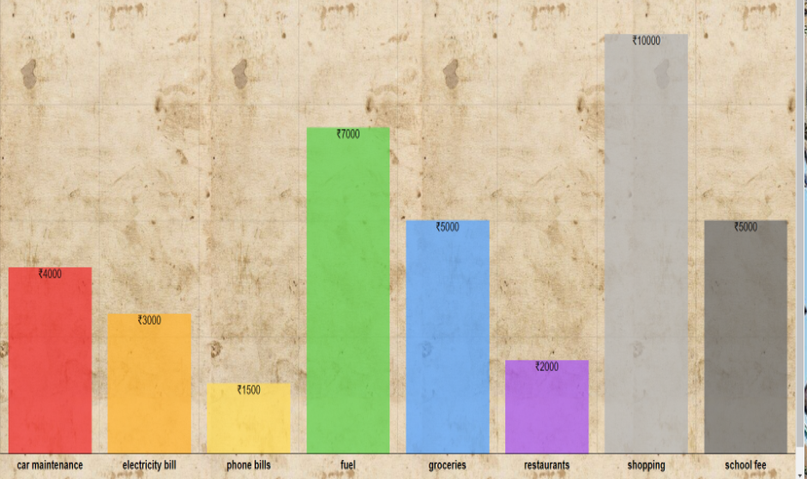

## PROBLEM STATEMENT

Main motive to build this website is to provide users a secure place where they can solve their financial problems with help of professional guides and unique features. Finance app makes it easier by helping users manage their finances easily and efficiently. The best personal finance app not only helps users with monitoring, budgeting, accounting and expense tracking but also gives helpful insights into money management. It also gives users various investments options, tax advices, insurance input, and above all, a proper security system.

Since handling money, managing loans, keeping a check on investments all are a deal of great headache and difficult to handle to make this task easier and more relaxing we have worked and provided user-friendly features.

Firstly, the main problem faced by a person is if he/she is thinking of buying a house or a car for example he has to juggle around with his finances and is unable to figure out whether he/she should do the purchase or not or if purchasing then how and when. This can be easily cleared by just a click. Also, sometimes we look for ways by which we can improve one’s financial status without interrupting the daily requirements. Our budget making calculator can solve this problem efficiently without you doing any hard work. Some even want to increase their saving by tracking where and by how much their money is being used or people also want to be ready for any sudden money issues in near future. All these problem and demands can be solved with the help of our website and will provide even more and advance features like taking advices from professionals.

Another problem faced by many is the immense paper-load when it comes to finance management even when they seek any professional for advices it requires time, travelling and bundles of forms. It is observed that even for purchasing a small piece of land it requires loads and load of paper work and written stuff. So rather than this, why not spend valuable time of yours to manage your money by sitting just at home, avoiding paperwork and using a user-friendly graphics website which is easy to use without wasting time in travelling and avoiding unnecessary expenditure.

Mobile finance apps also provide you with unprecedented insight into your overall financial health. How close are you to reaching your savings goals? How much money are you spending compared to what you’re earning? For example, you could use Mint to track all your money coming in and going out, Pocket Guard can help you stop spending money you don’t have, and earning to access your pay check before payday if you have expenses due before it comes in.

# TECHNICAL DETAILS

HTML --- hypertext markup language, it is a markup language for describing a web document. A markup language is a set markup text. Each html tag describes different documents text.html consists of series of elements. These elements tell the browser how to display content Html tags are key words surrounded by angular brackets.

CSS --- stands for cascading style sheets. It describes hoe html elements are to be displayed on screen, paper, or in other media. CSS saves a lot of work. It can control the layout of multiple web pages all at once. External stylesheets are stored in CSS files. -

As we have got this project under the subject ‘FRONT END ENGINEERING’ we have mainly used HTML and CSS codes.

Mainly used tags are: -

1. Title tag
2. Division tag
3. Anchor tag
4. Hyper reference tag
5. Image tag
6. Video tag
7. Font tag
8. Hr tag
9. Marquee tag
10. Heading tag
11. Footer tag
12. Table tag
13. External CSS
14. Internal CSS
15. Inline CSS

BOOTSTRAP --- A technique of loading a program into a computer by means of a few initial instructions which enable the introduction of the rest of the program from an input device.

the technique of starting with existing resources to create something more complex and effective:

JAVASCRIPT --- An object-oriented computer programming language commonly used to create interactive effects within web browsers.



# Technical Details(II)

Now some pages following this page are of utmost important. This is because starting from this page we have described beautifully about our website and how we have built our website pages.

A) **Home Page:**

In our home page we have given a brief introduction about Personal Finance Manager, his job, advantages and disadvantages of working in offline mode in field of finance and its related topics. We have tried to promote paperless accounting by raising some facts that show how paperless accounting is efficient and one should use online methods of dealing with money, like using our website for managing their finances.

Talking about our homepage, it has been majorly made with the use of HTML and CSS with a little use of Bootstrap to enhance it. Starting with our navigation bar, we have made it using Bootstrap with the use of "navbar" class. Also, dropdowns and colours in the navigation bar have been set using the bootstrap. Now internal CSS has been used to give a beautiful look to our homepage by choosing the background colours of the page and also the gradient colours in Headings. Talking about HTML, we have used Table tag (For Table), Marquee Tag (For Sliding of photos), img tag, br tag, paragraph tags, strong tag (For boldness), centre tag and Footer tag (For Copyrights). At last JavaScript has been used to design a button named "Top" to navigate to top of the page. The function used here is onscroll (). This was all about the HOME PAGE.

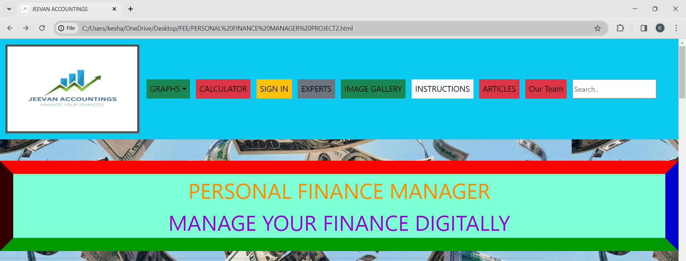

B) **Calculator Page:**

The Calculator page in our website is very beneficial for our users. Calculator page is mainly to built to make calculations easier and it will help to avoid mistakes in long and complex calculations. We have variety of calculators in website. These are provided so as user can do all of his/her work on a single page and in a single domain. Because switching between websites again and again can make easy work difficult and complex.

So, Calculators provided by us are:

1)Loan Calculator:

It helps to calculate monthly loan payment. User should enter his Loan Amount, Annual Interest Rate and Loan Term (in years) to calculate loan payment.

2)Saving Calculator:

It helps to display future savings. User should enter Initial amount he/she has with them, how much they will deposit monthly, their annual interest rate and how many years they have to follow this (or for how many years they want to save money).

3)Budget Calculator:

It helps to calculate how much one has spent in a month. In other words, how much were the expenses in a month.

4)Investment Calculator:

It helps to calculate future investments. Just enter your initial investment, annual interest rate and duration(years).

At last, we have also added "Saving Guide”, so that our user can take some tips to save money and have a great future. Also, we have added "Return" button so it makes navigating through the website easier.

Now in this page major work is of JavaScript and Bootstrap, because this page is the most operational page of our website which includes calculations and printing results simultaneously. From Bootstrap Dropdowns have been used. From JavaScript, functions such as parseFloat (), getElementById, parseInt(), have been used. Form Tag has been used from HTML and Internal CSS has been used.



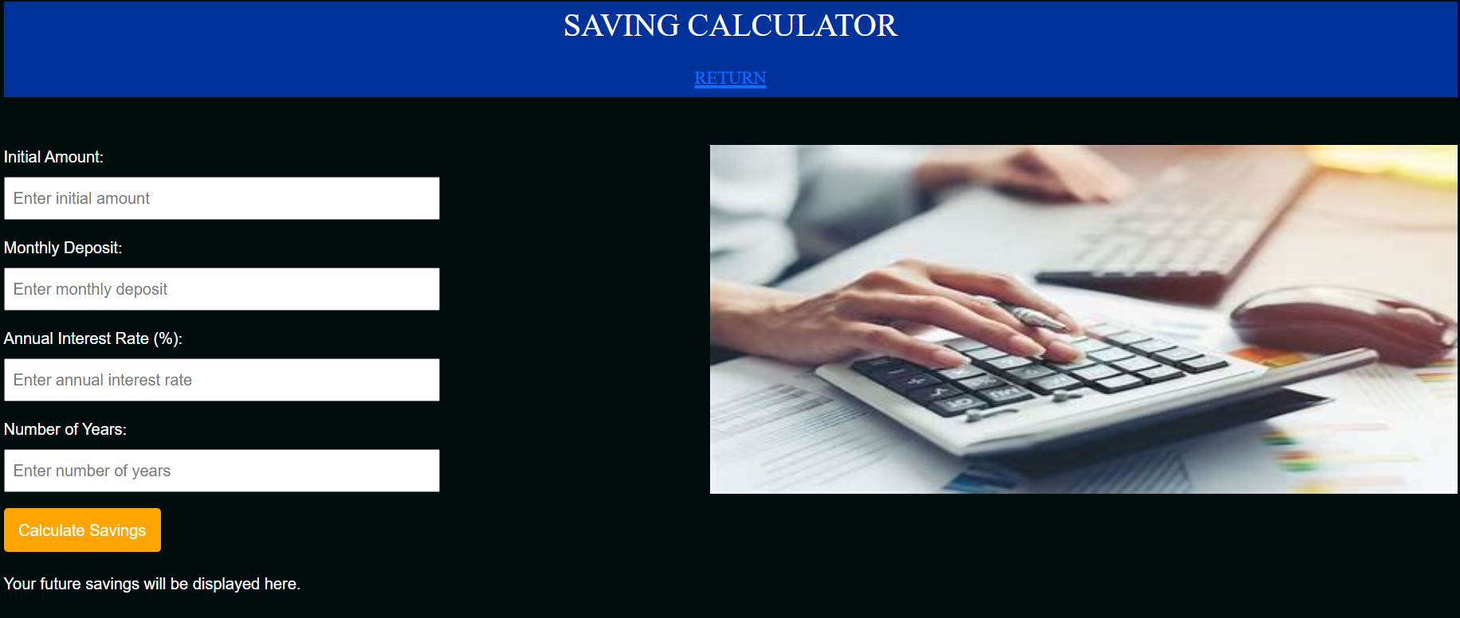

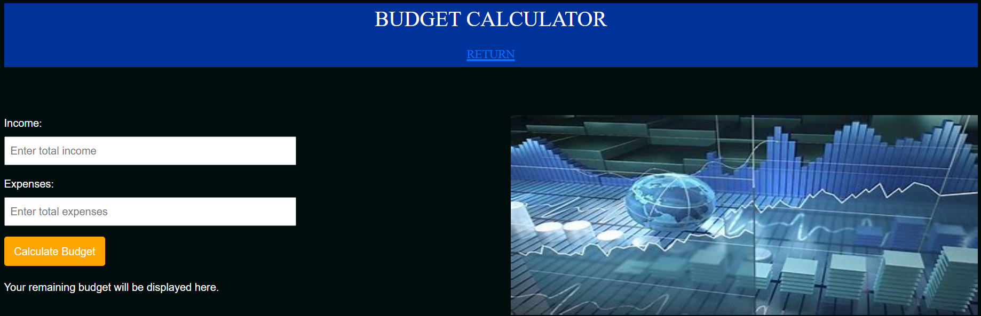



# C)**Sign UP Page:**

# This page is designed to collect contact information from potential customers, such as their name, email address, and phone number. A user should enter Firstname, Secondname, Email and Password. "Reset" and "Submit" button have been provided.

# In this page, JavaScript has been used to make the page operational. Moreover, it is a signup page so it requires a lot of functions of JavaScript such as we have used, onmouseup(), onmousedown(), onfocus, onsubmit, onreset and alerts. Internal CSS has been used to give the website the proper look it needs.

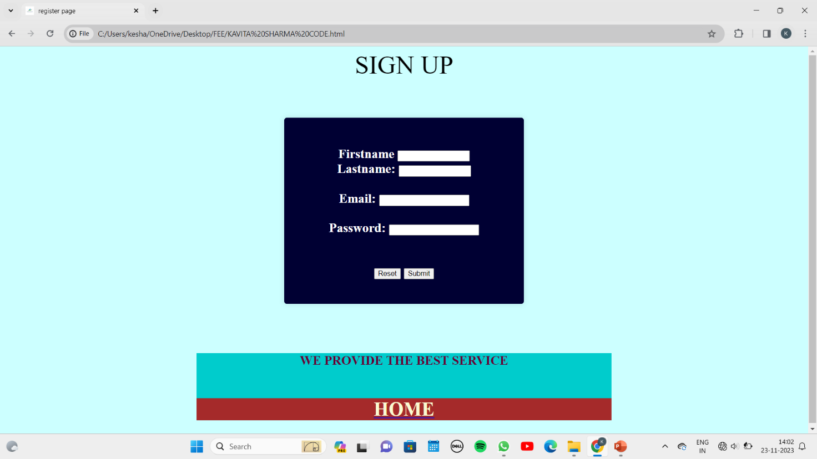

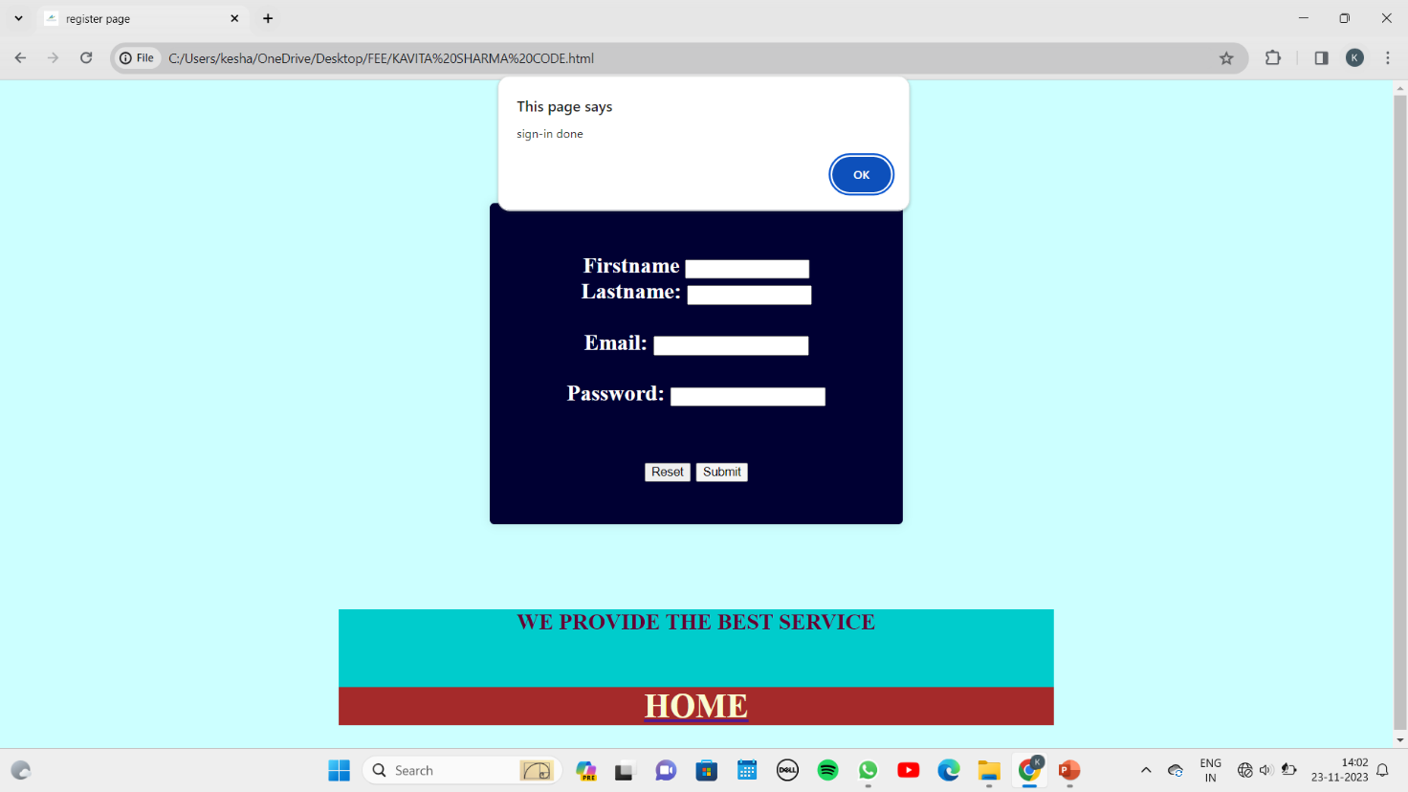

D) **Expert Page:**

We have mainly designed this page so that our customers who want to clarify their doubts regarding finance can contact these individuals so that users can be guided deeply.

Functions such as onclick, getElementById are used from JavaScript. Internal and Inline CSS have been used majorly. Forms are used from HTML.

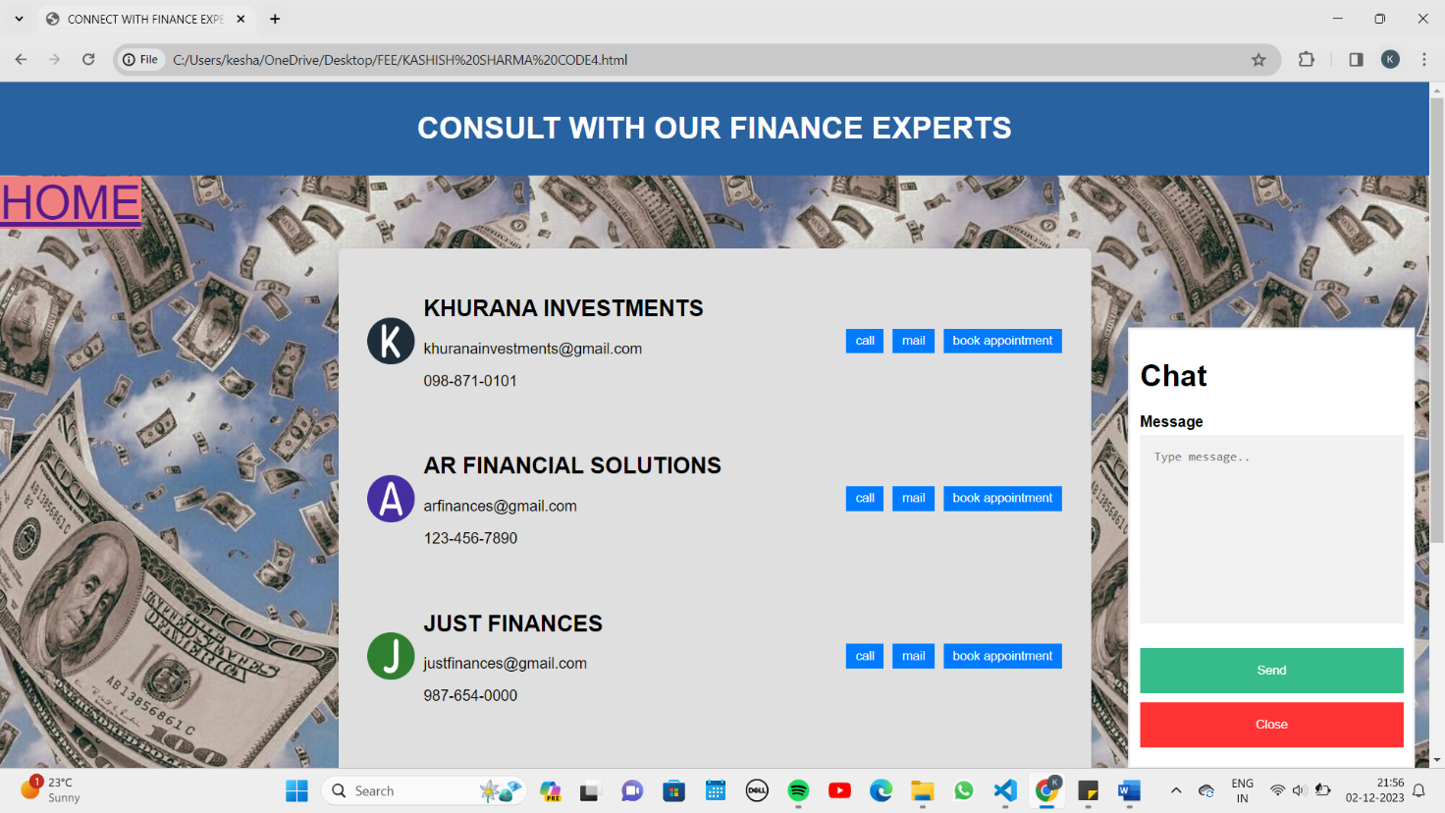

# E) **Image Gallery:**

# Our main purpose to make image gallery was to make the website to look more illustrious. So that people do not get bored and rather feel motivated to see pictures related to becoming save money and becoming rich. We have even inserted pictures that have quotes in them.

# The most used function here is onclick function of JavaScript. Also concept of lightbox image Modal Image Gallery have been used from HTML. Image tags, Inline CSS and External CSS have played major role. Using functions such as plusSlide(+1), plusSlide(-1) inside the onclick function has been useful in switching of pictures to previous or switching to next image.

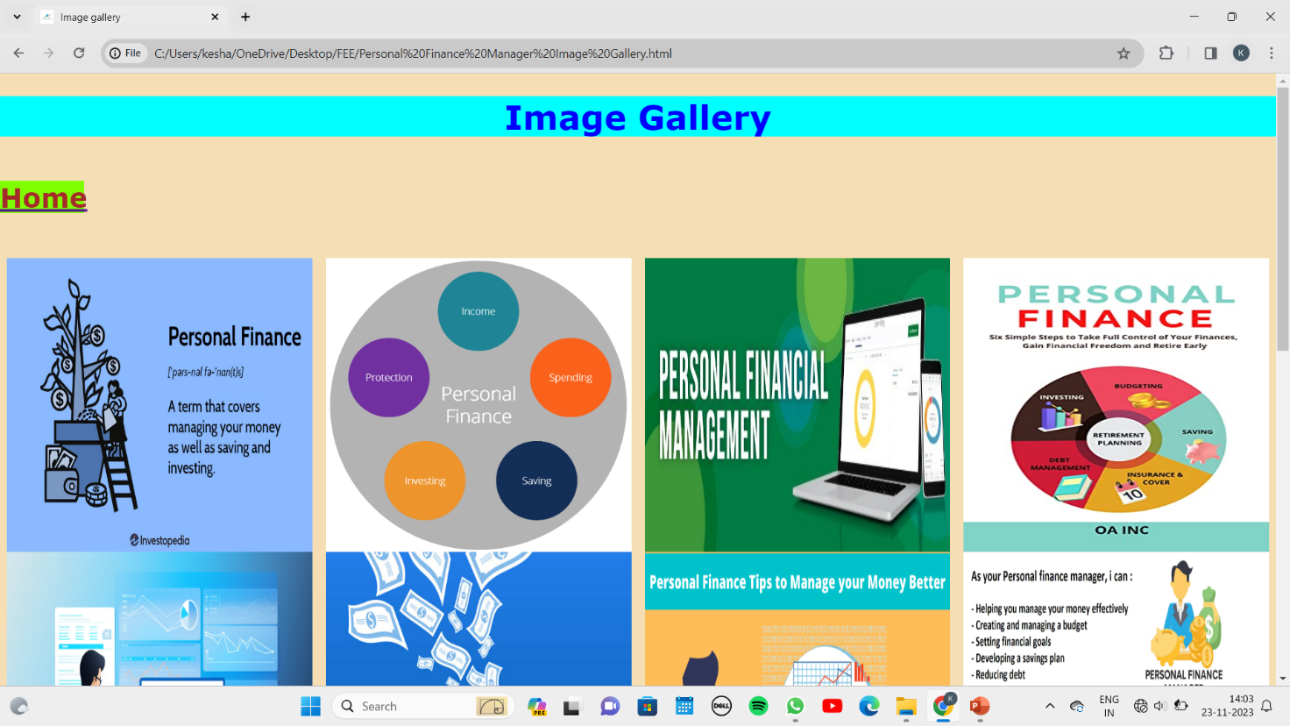

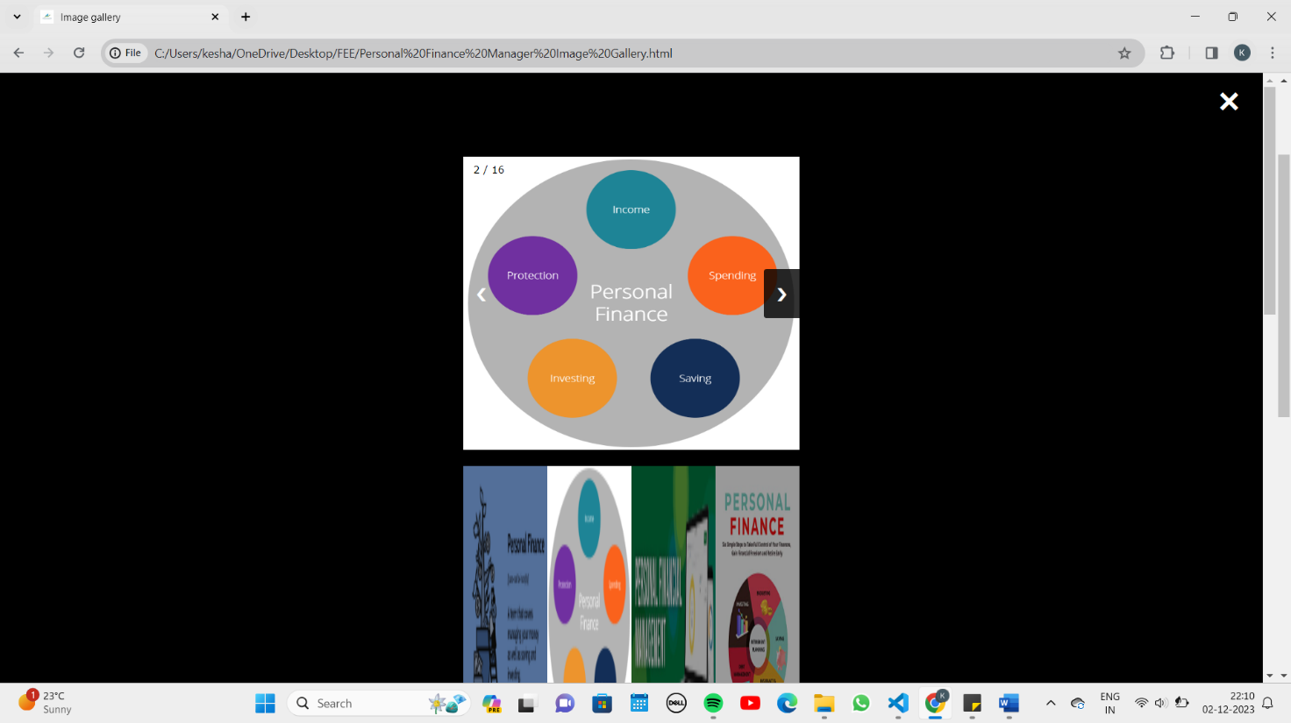

# F) **Instruction Page:**

# Instructions page is another important page in our website. The main motive behind designing this page is that user should know how to use the website correctly and pick up the correct benefits of the website. It is just like that in general all human beings have to learn something before trying it like driving or swimming. before knowing all the features of the car, it makes no sense of driving it because you cannot use the car to its full potential for which it has been made. On this page even a dialog box named "Terms and Conditions" is given so that our user can read them understand the aspect of our website all the related risks related to finance.

# Bootstrap has been used majorly. Breakpoints have been used to make the site responsive. This has been done with the help of media queries. Alerts have been added to the top of page. Buttons such as "Some Screenshots" and "Customer Care” have been added to the website with the help of bootstrap. Then a "Contact us" form is designed to clear queries related to the usage of website. "TOP" button has added with the help of java scripts. on scroll function has been used from JavaScript. Terms and Conditions have been made using the MODAL class from bootstrap. Span classes, unordered lists, image tags have been used from HTML. From CSS inline and in5ternal CSS has been used.

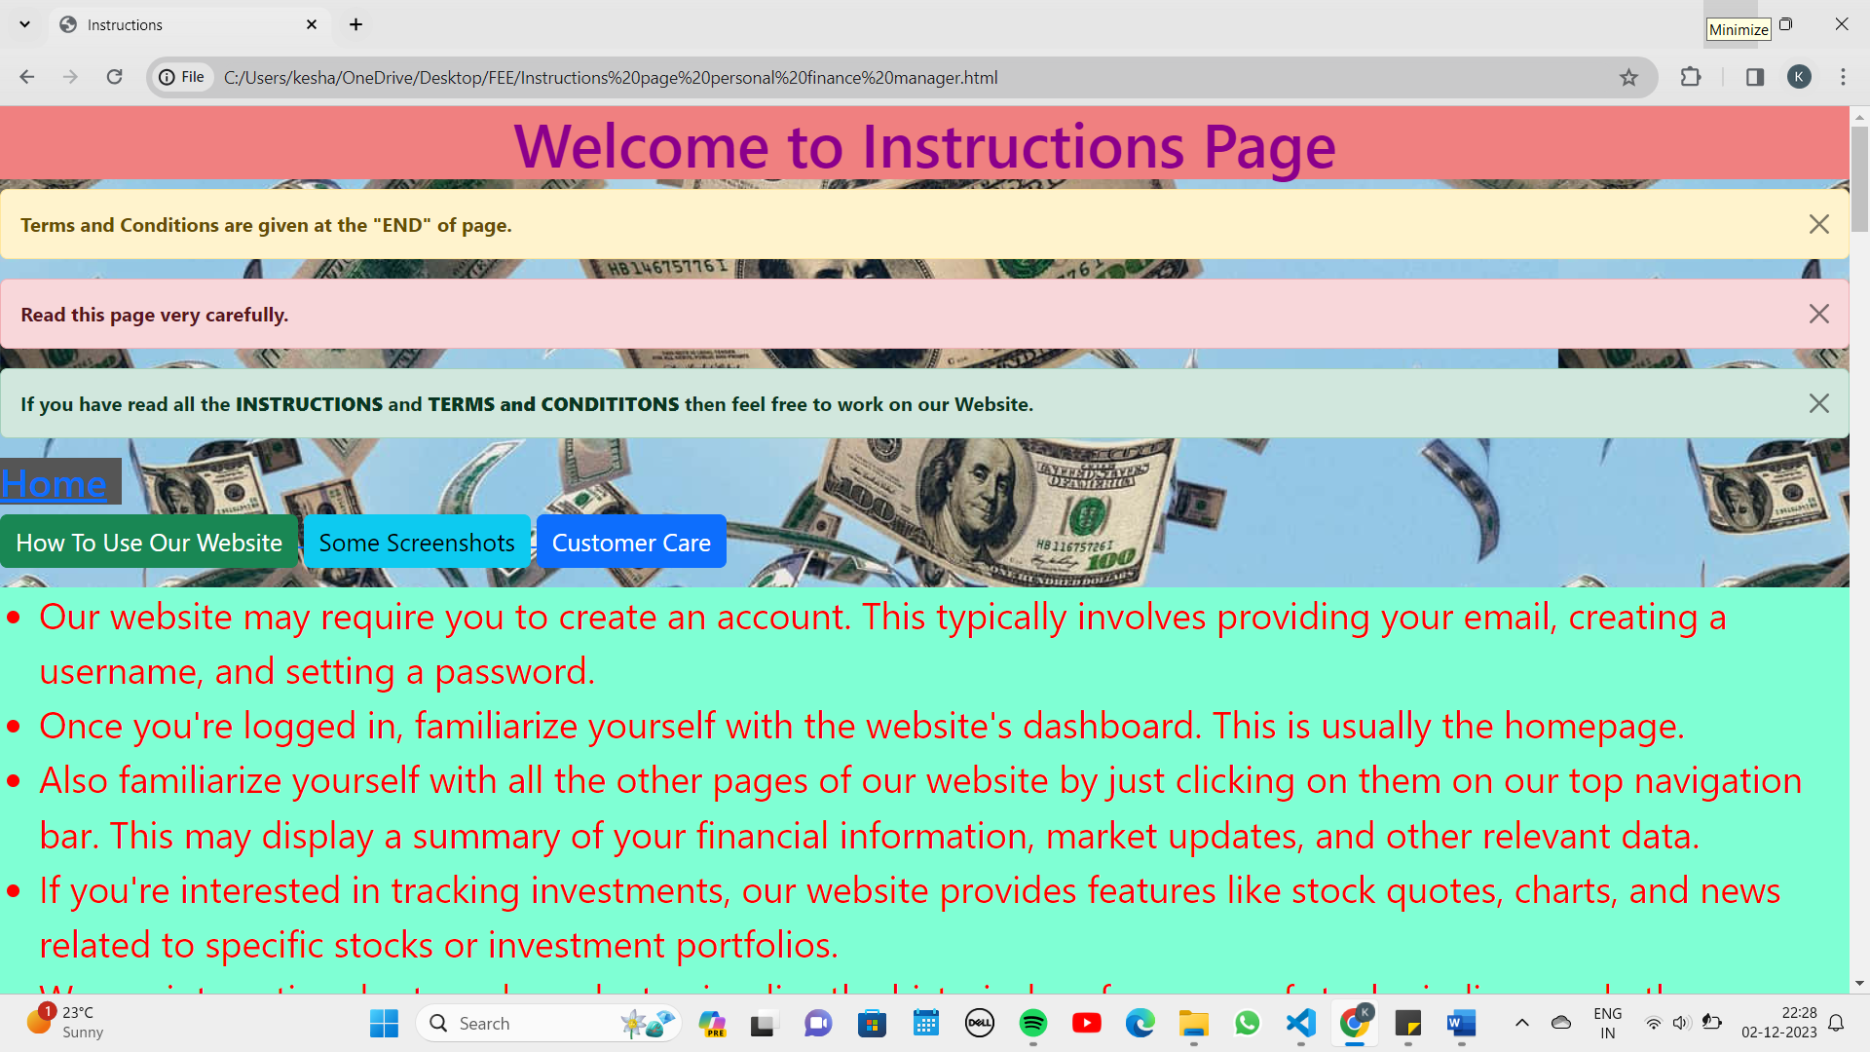

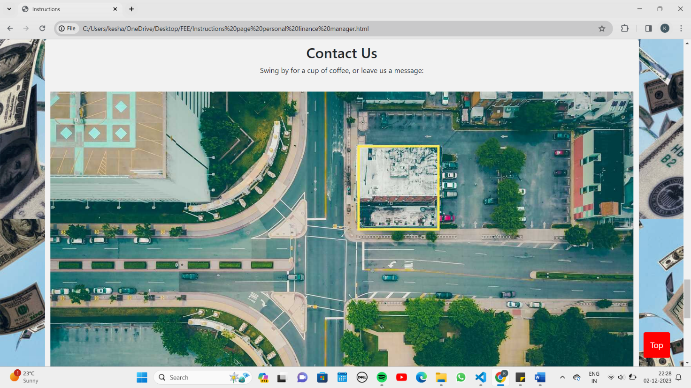

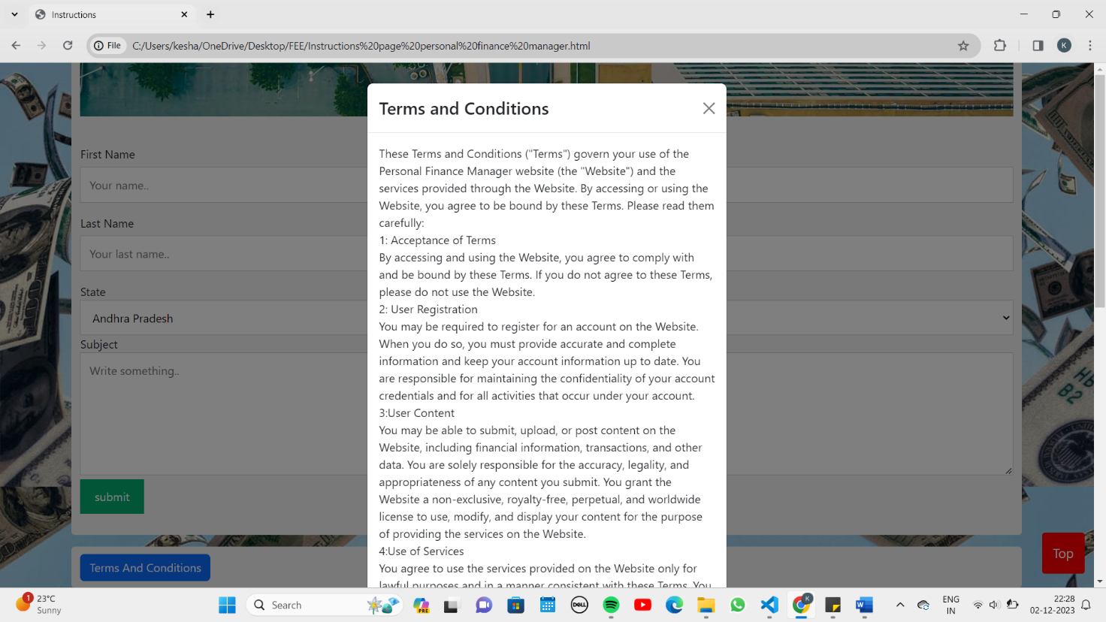

G) **Articles Page:**

This page is added to increase knowledge of users in field of finance and the term personal manager. This page contains articles such as "Art of Investing" and "Art of Budgeting". We have also provided users with live links of Stock market, Some Blogs, etc. We hope that our user gains some meaningful information from this page.

This page has been built using Bootstrap. The navigation bar, Panels (in which articles are written), Jumbotron (For headings), Dropdowns, Collapsible (For more information and live stocks), active and deactivate lists, are all from Bootstrap. Even background colours used in aal of the above mentioned have been used from Bootstrap. We have installed "TOP" button with the help of onscroll function from JavaScript.

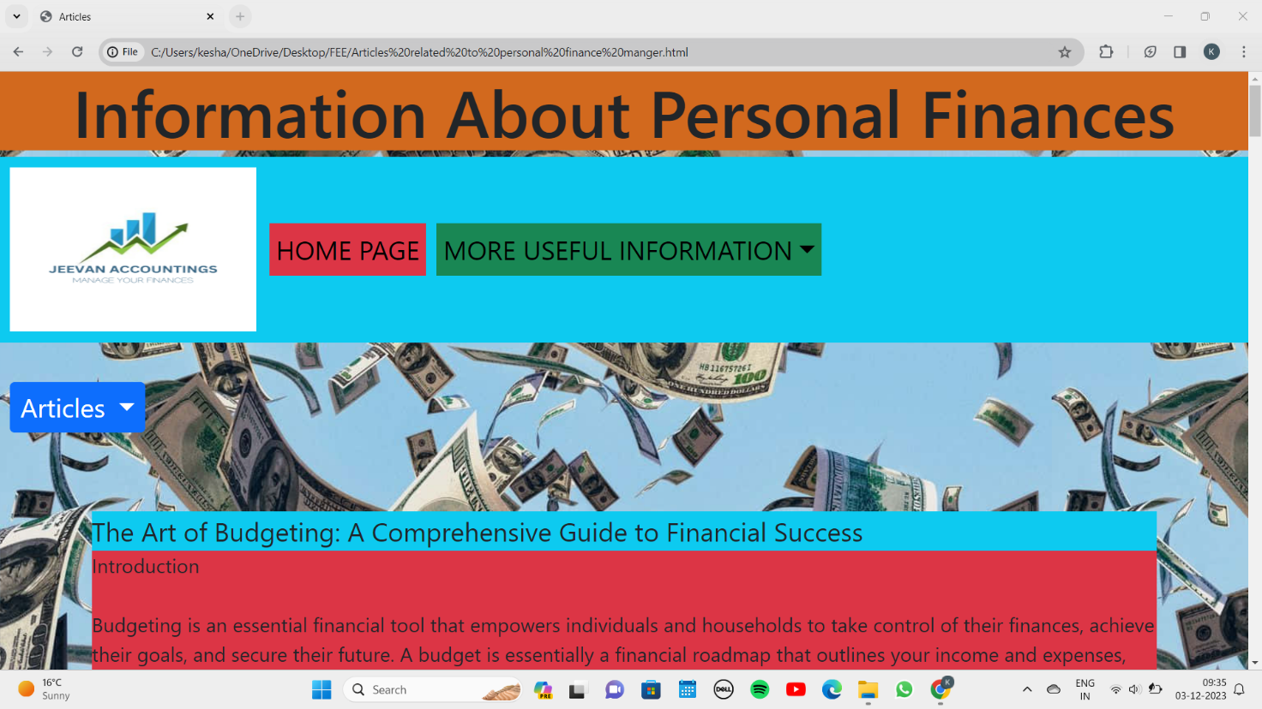

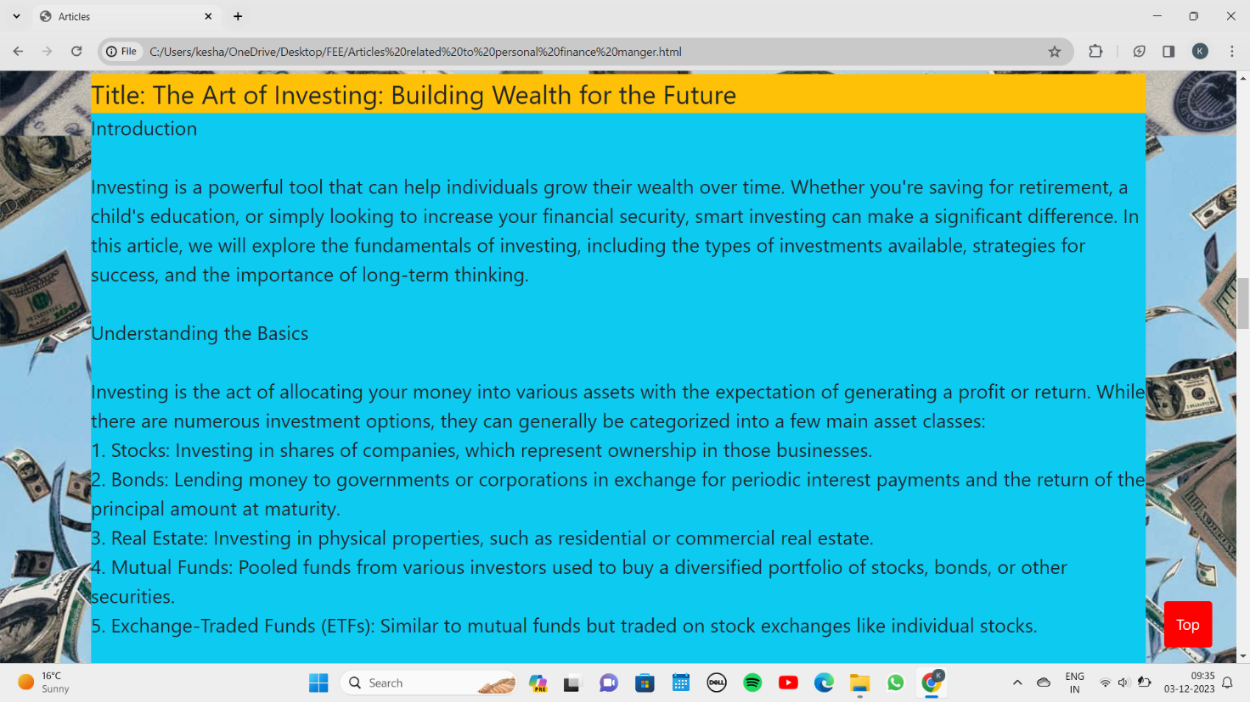

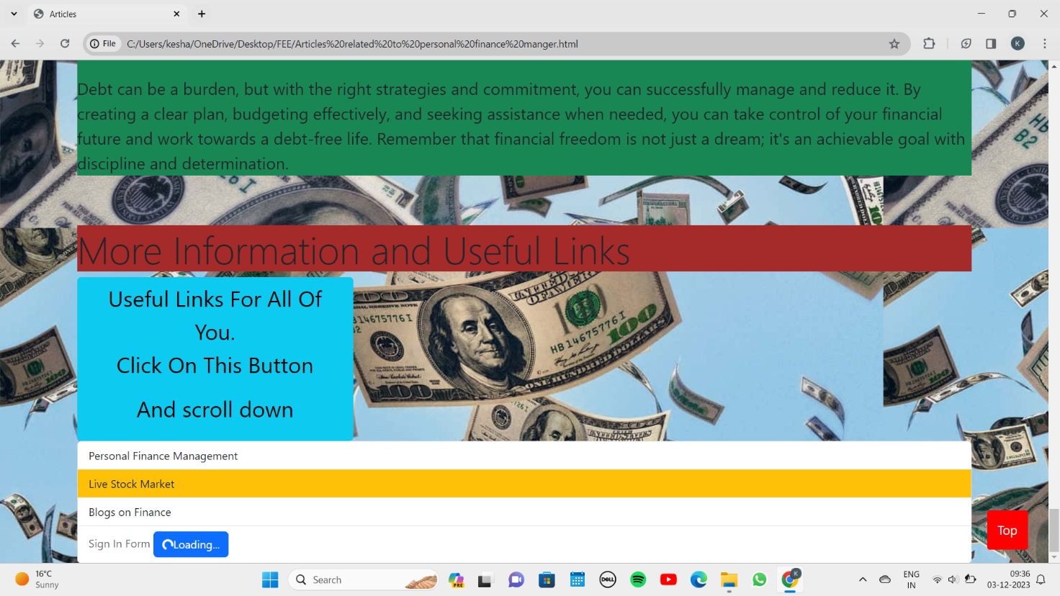



H) **Team Page:**

The only purpose to design this page is that our should feel free to contact us through emails and our phone numbers so that we would clear their doubts about the website.

This page has been designed with the help of Table tag in HTML, and Footer tag has been used for the copyright section.2

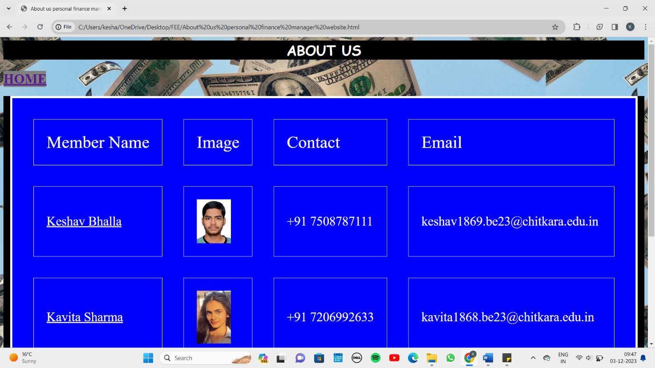

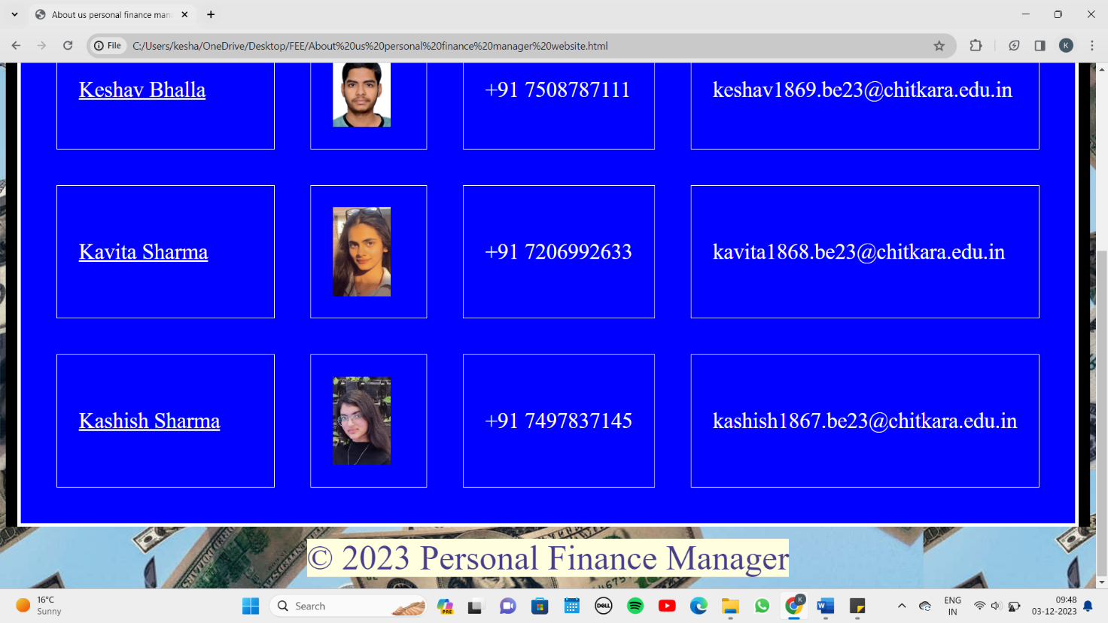

# KEY FEATURES

One of the key features of our website is that we provide the users graphs. it creates an interactive charts, graph, and other visualizations, finance teams can quickly and easily communicate complex financial date to stakeholders.

We provide 3 types of graphs:

1. Income sources
2. Expenses by sub categories
3. Monthly Income

Another unique feature we have added in our website is that we have provide our user not only with expenses calculator but also with other different types of calculators.

We provide 5 types of: -

1. Loan calculator
2. Saving calculator
3. Budget calculator
4. Investment calculator

* Our key features also include notifications that will be provided in our website to our user so that they remain alerted not only to their spendings and savings but also get aware time-to-time about shares they are currently investing in.
* Sometimes people get bored discussing about finance and checking their finance websites. So, to resolve this issue we have used different animation, video, and in future we would be trying to add features like providing our users with interacting sessions on finance with renowned experts. This will help them to develop their knowledge in finance field.

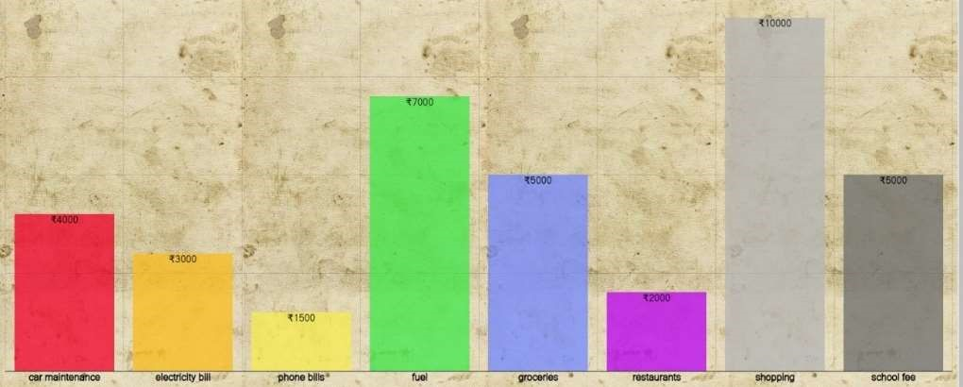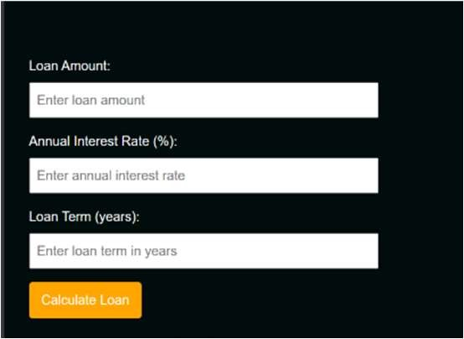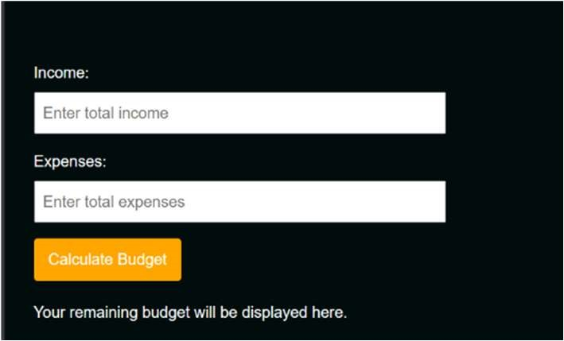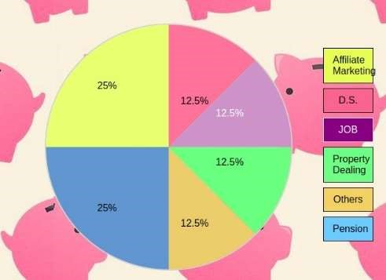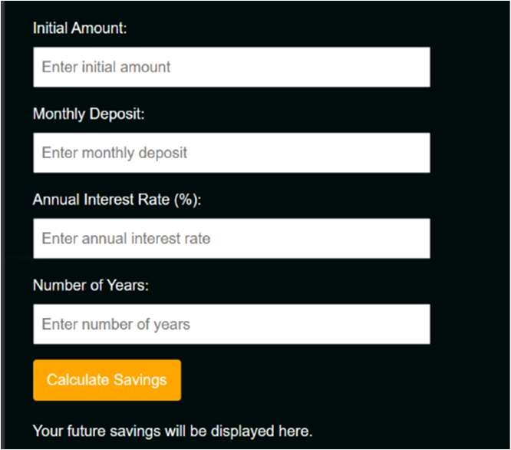

# PROJECT HIGHLIGHTS

Logo

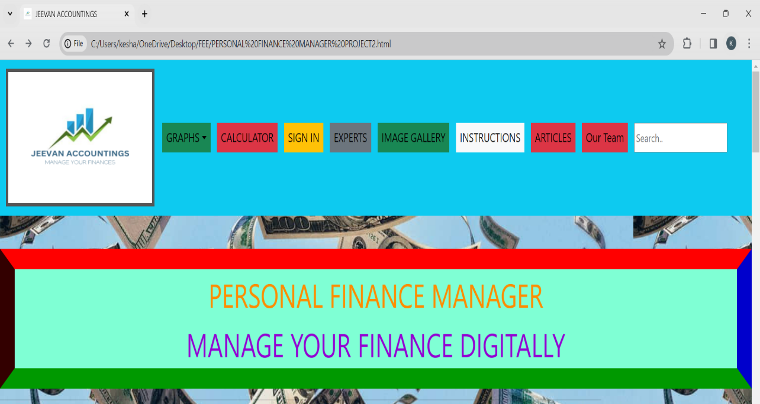

Navigation Bar

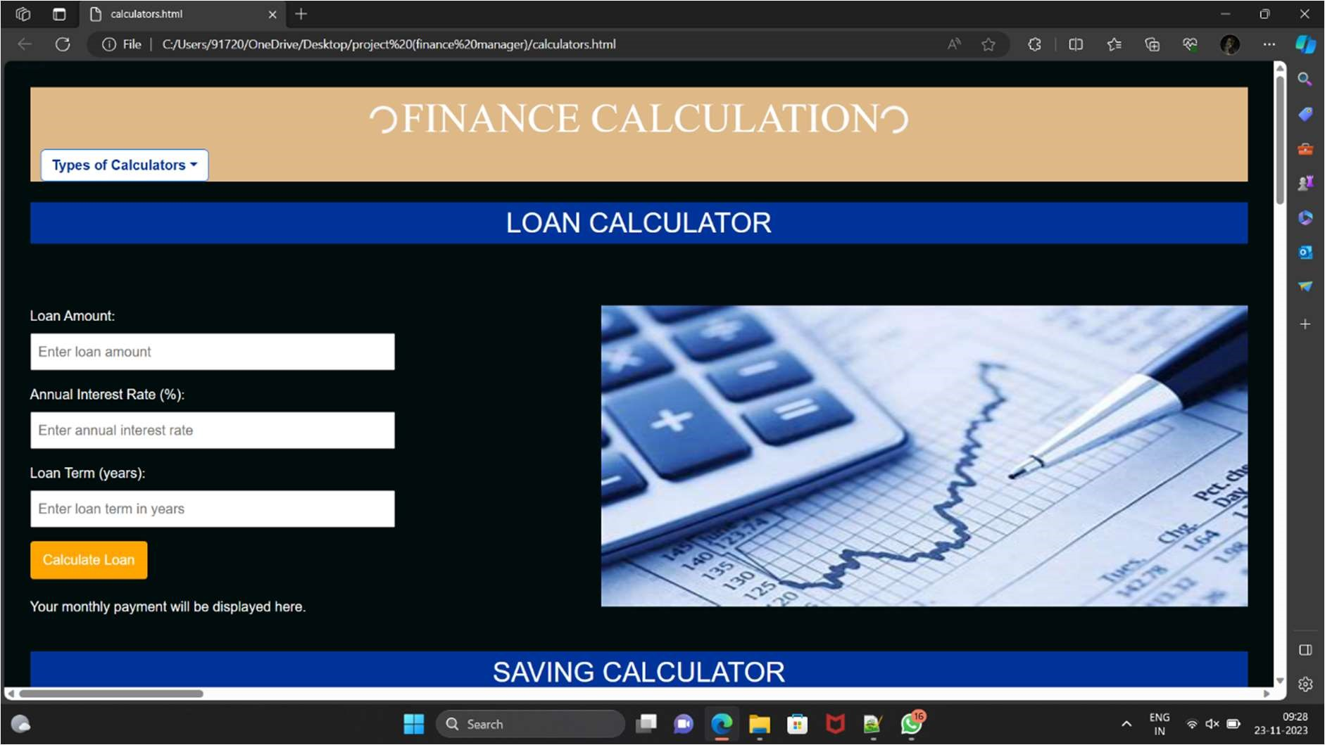

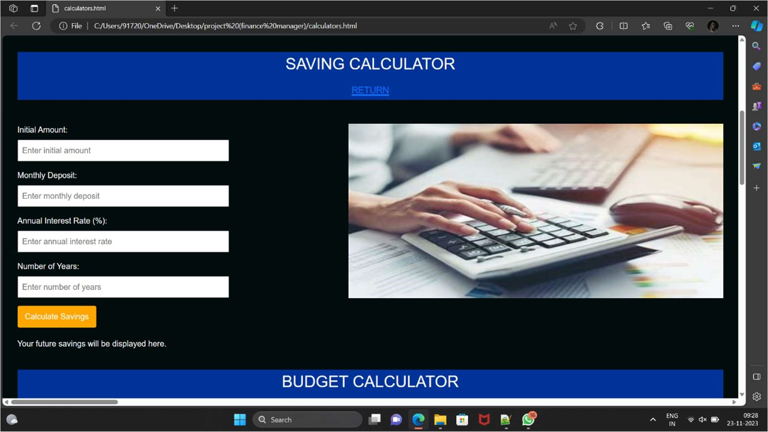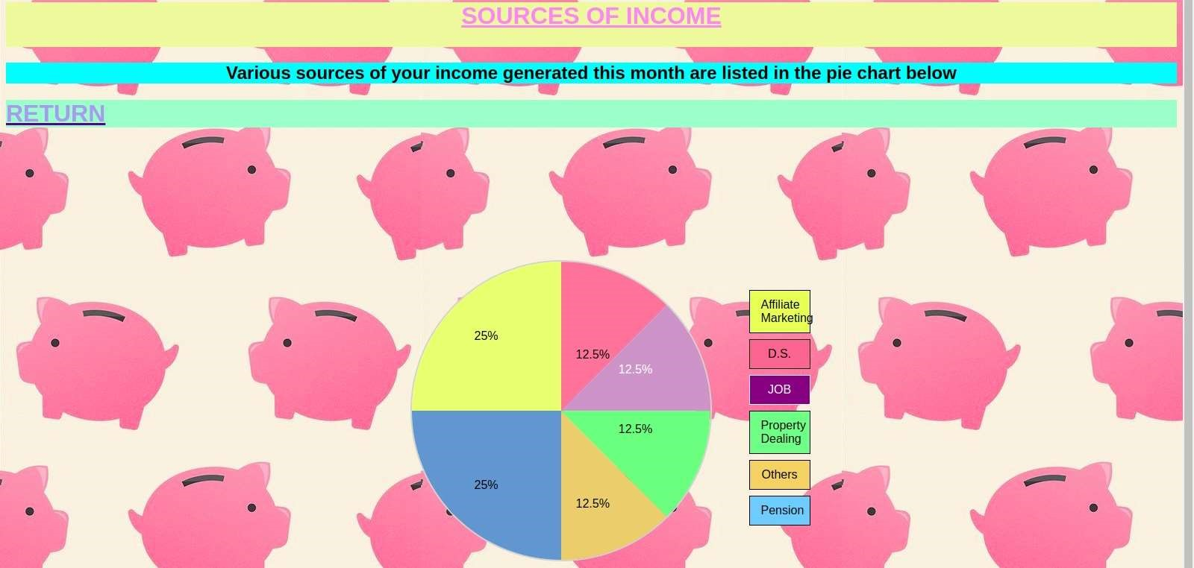

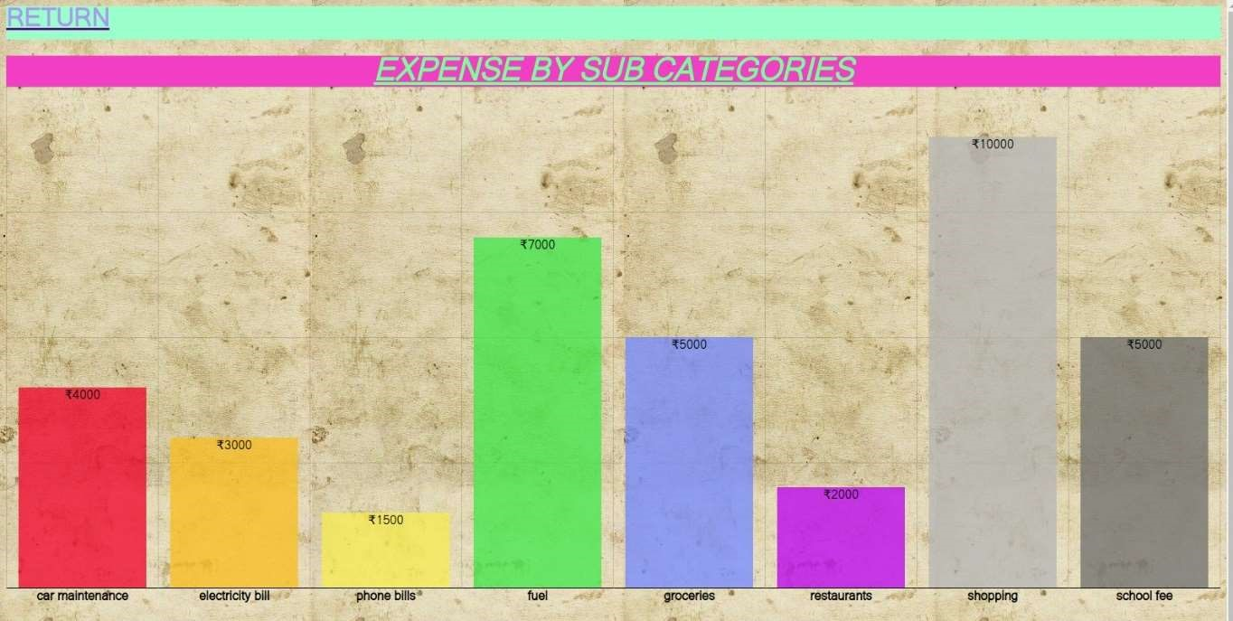

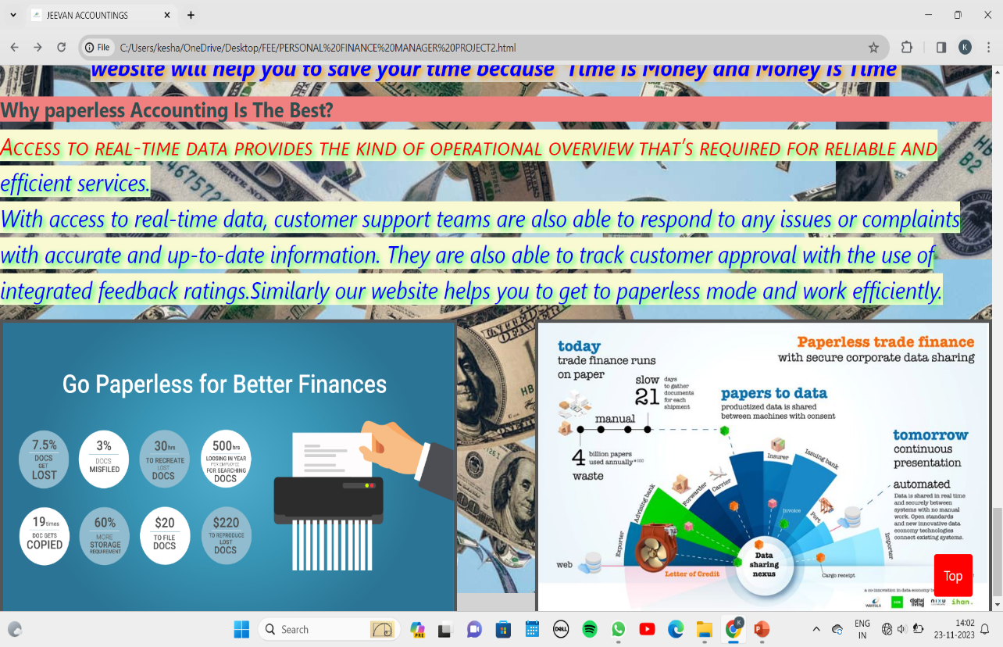

# BONUS FEATURES

The bonus feature of our website is that we give the access to the users to take advices from trusted finance professionals with spending even a rupee. We provide a list of renowned experts of financing with there contacts so that with there help you can get even more benefits.

Sometimes we get puzzled and get stuck while making a decision when it comes to purchasing something big or while making a budget. To get answers to questions like where to compromise with money and where is necessity to spend our professionals will show you light and will clear all your doubts.



# CONCLUSION

Making a website is really a dream for a computer science student. Also, making website is really fun for a developer.

Similarly, for our team making a website has always been interesting and fun.

Though, we made a lot of mistakes while doing our project, we have learnt of lot about HTML ,CSS, Bootstrap, JavaScript.

We learnt most important things that is teamwork which will be beneficial for our future, as we might be handling bigger projects in our future studies.

We learnt the following:

1. Introduction to HTML
2. More to HTML
3. Forms
4. Introduction to CSS
5. Styling with CSS
6. Flex
7. More on styling
8. Responsive Design
9. Modals and Panels
10. Alerts
11. Collapsible
12. Dropdown and Navbar
13. Breakpoints
14. Onfocus event
15. Onreset event
16. Onsubmit event

At the end, making this website was a really good experience for a full stack developer.

REFERENCES

W3School:- HTML Tutorial (w3schools.com)

Render Forest:- All your design tools in one place | Renderforest

Canva:- Canva: Visual Suite for Everyone



